**DAILY ONLINE ACTIVITIES SUMMARY**

|  |  |  |  |  |  |  |  |  |
| --- | --- | --- | --- | --- | --- | --- | --- | --- |
| **Date:** | **19-05-2020** | | | | | **Name:** | **Sinchana** | |
| **Sem & Sec** | **6 B** | | | | | **USN:** | **4AL17CS117** | |
| **Online Test Summary** | | | | | | | | |
| **Subject** | | **CGV** | | | | | | |
| **Max. Marks** | | **60** | | **Score** | | | **55** | |
| **Certification Course Summary** | | | | | | | | |
| **Course** | **Selenium Web Driver with Java** | | | | | | | |
| **Certificate Provider** | | | **Dmitry Shyshkin**  **(Udemy)** | | **Duration** | | | **6.5 hours** |
| **Coding Challenges** | | | | | | | | |
| **Problem Statement: 1. Substring. 2.Shortest palindrome 3.Linked list palindrome** | | | | | | | | |
| **Status: Success** | | | | | | | | |
| **Uploaded the report in Github** | | | | | **Yes** | | | |
| **If yes Repository name** | | | | | **coding** | | | |
| **Uploaded the report in slack** | | | | | **Yes** | | | |

Online Test Details: (Attach the snapshot and briefly write the report for the same)

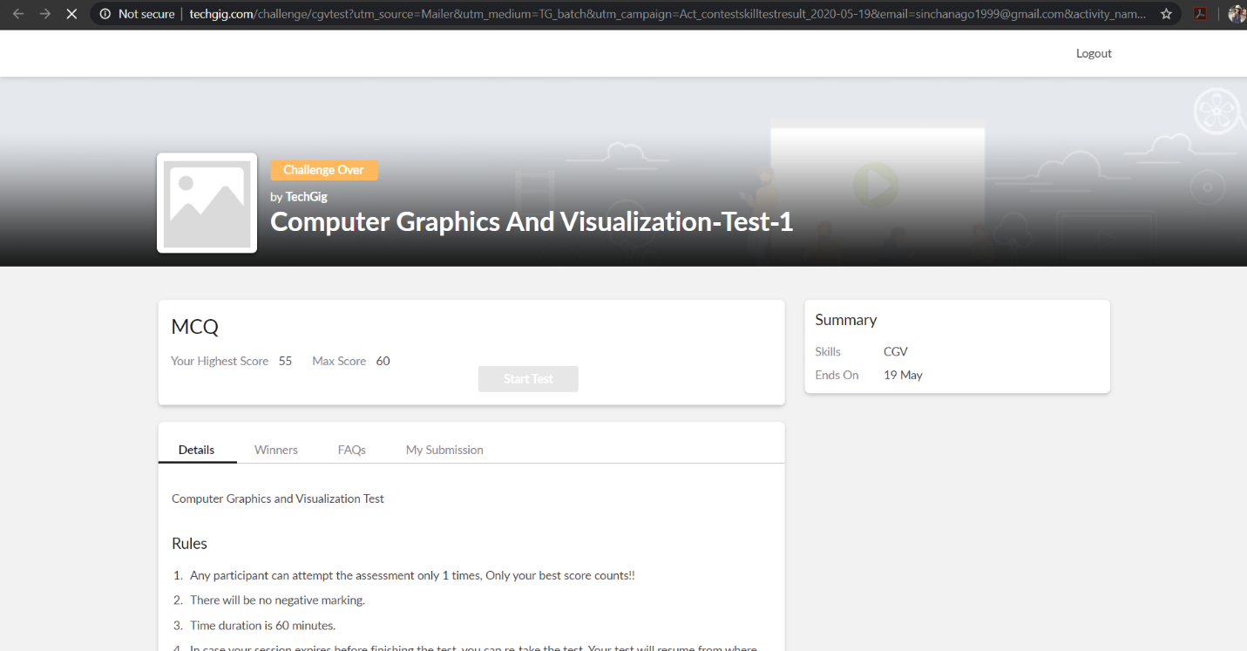

The test was held between 9:00 am to 10:00 am. It consisted of only 1 round and the total marks assigned was 60.The above snapshot is the output of my 1st IA test.

Certification Course Details: (Attach the snapshot and briefly write the report for the same)

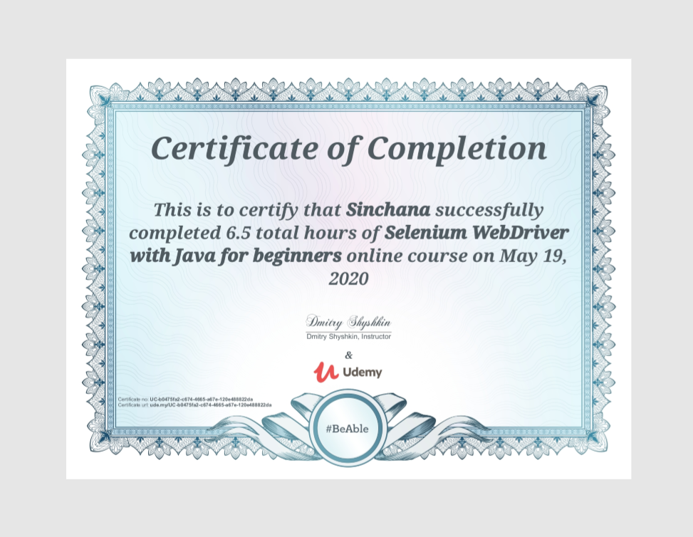

I have learnt to use TestNG features for better test structure and easy selenium framework maintenance. Even to recognize different selenium test failures and exceptions and know how to fix and avoid them.

Coding Challenges Details: (Attach the snapshot and briefly write the report for the same)

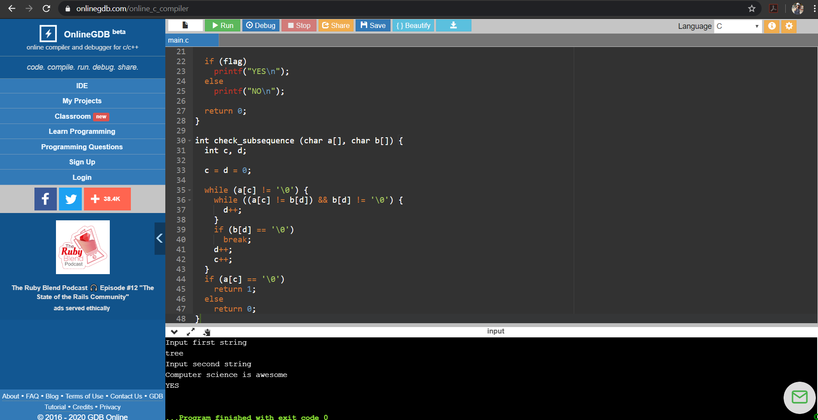

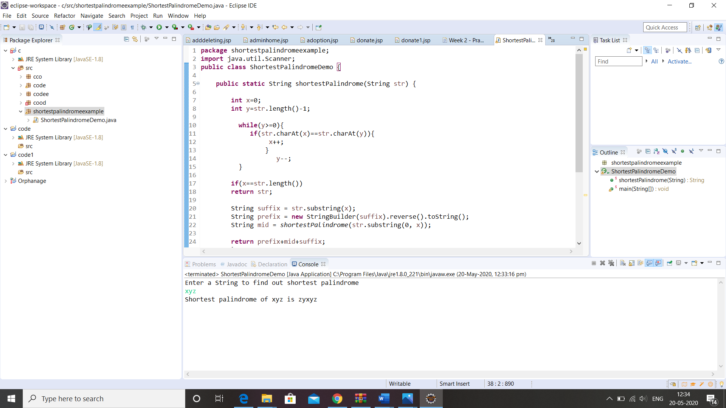

Link for coding in GitHub : <https://github.com/sinchana514/coding>

Link for certificate in GitHub : <https://github.com/sinchana514/certificate>